SIGraDi Formatting Guidelines: Title in Arial 14, Bold and Left Alignment
SIGraDi Formatting Guidelines: Title in English, in Arial 12 Bold and Left Alignment

First Author in Arial 9, Bold Third Author in Arial 9, Bold Institution, Country in Arial 9 Institution, Country in Arial 9
Email address Email Address

Second Author in Arial 9, Bold Fourth Author in Arial 9, Bold Institution, Country in Arial 9 Institution, Country in Arial 9
Email address Email Address
Please maintain alignments along the paper –

Abstract
The abstract should be located under the authors’ information. It must be written in one paragraph, in English, in Arial 9 normal and justified. It should be 100 words maximum.
Keywords: Up to 5 keywords; Written in Arial 8; Justified to the left; First letter capitalized; Separated by semicolon

Introduction
The aim of this document is to provide guidelines for your full paper or Short Paper submission. Following these instructions facilitates preserving your original paper layout in the SIGraDi 2015 Proceedings. To simplify the formatting task, we recommend you to substitute these instructions with your original work. Please keep in mind that the deadline for submission is September 14th, 2015, and at least one of the authors should be registered by September 21st, 2015.
To facilitate the editorial work, full and short papers must be uploaded to the conference website in .doc or .docx format. The name of this file will be PaperID.doc (or docx). You can optionally upload a ZIP or RAR file including the document and figures. Papers that do not follow the requirements or those saved as PDF will not be accepted.

Document Layout
For Full Paper, a minimum of 5 and a maximum of 8 pages in letter size will be assigned per publication. For Short Paper, a minimum of 3 and a maximum of 4 pages in letter size will be assigned per publication. The number of words reduces when the number of images increases.

Columns and margins
The final document will be printed in letter size, doublecolumn format, exactly as this document. Therefore, you should not modify the columns or the margins. Top margin is 1 inch; and left, right and bottom margins are 0.75 inches each. The distance between columns is 0.2 inches. Please do not insert page number or footnotes in this document.

Text
Please use Normal Arial 9 for body text. Italics must be used only to emphasize names, technical terms, or words in other languages. “Only direct quotes should be in quotation marks, Arial 9 (neither bold nor italics), and without numbering.” Details about citations are described in the citation section.

Sections and Subsections
The heading of the main sections of the paper such as introduction, methodology, results and conclusions should be in Arial 12, bold with the initial letters of each word capitalized. Note that short words such as the, for, or and are not capitalized.

Subsections sample
The heading for subsections should be in Arial 10, bold, with only the initial letter capitalized.

Tables and Figures
Place the entire table within the document, below and as close to the reference as possible, in the same page. Place the reference above the table. Please number the tables or figures from 1 to 6, as the example below.

Table 1: A description should be placed above the table, in Arial 8, justified to the left. Text inside tables should be Arial 8.
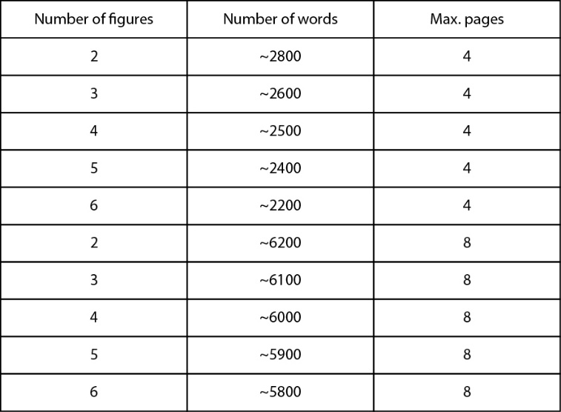

Figures

Figure 1:

The description should be located below the figure, Arial 8.
Lee and Lee (1991) rated the paper as “the best in its field” (p.14)

For final publications, original images should be uploaded independently of the paper. Original images should be saved in *.jpg format (higher quality), and a resolution of 300 dpi. For editing your images, please keep in mind that the proceeding will be printed in black and white. Image files must be named as following:
- PaperID-01.JPG
- PaperID-02.JPG

Figures should be inserted into the document as reference only. These images should fit into a column; therefore they should be 8.63 cm (3.4”) wide. If necessary, figures and tables may extend across both columns to a maximum width of 17.78 cm (7”). The wide images can be located only at the beginning or end of each page (Figure 1), but not at the center of the page. To do so, you should select the image and its description, and assign them column style One.

Citations
We will use APA 6th citation guide for formatting references. You are encouraged to use Endnote Reference Software (or similar) to automate the citation task and avoid errors. Citations should be in parenthesis indicating the author last name and year of publication separated by commas (Author, Year). Please, find the four types of citations in context below:
- Indirect Quotation with Parenthetical Citation: Description of the content (Lee, 2007).
- Indirect Quotation with Author as Part of the Narrative: Lee (2007) shows that…
- Direct Quotation with Parenthetical Citation:
“Quotation” (Lee & Lee, 1991, p. 14).
- Direct Quotation with Author as Part of the Narrative:
Lee and Lee (1991) rated the paper as “the best in its field” (p.14)
If one or more articles must be referenced in one citation, please separate them by semicolons (Author1, year; Author2, year). If you reference two or more publications of the same author, published the same year, please add a letter after the year, for example (Author1, 1998a; Author1, 1998b).
References must be at the end of the text, in the References section. They must appear previously mentioned in the text.
References should be ordered alphabetically (followed by year), without numbering them. Journals, chapter of books, and online sources have different references formats, all detailed in the References section.

Acknowledgments
We thank to the SIGraDi Executive International Committee for providing the basis of this formatting style.

References
[For Journals, magazines, newspapers in print format:]
Williams, J. H. (2008). Employee engagement: Improving participation in safety. Professional Safety, 53(12), 40-45.
Keller, T. E., Cusick, G. R., & Courtney, M. E. (2007). Approaching the transition to adulthood: Distinctive profiles of adolescents aging out of the child welfare system. Social Services Review, 81, 453- 484.
[For Magazine Articles:]
Mathews, J., Berrett, D., & Brillman, D. (2005, May 16). Other winning equations. Newsweek, 145(20), 58-59.
For Books:
Alexie, S. (1992). The business of fancydancing: Stories and poems. Brooklyn, NY: Hang Loose Press.
American Psychiatric Association. (1994). Diagnostic and statistical manual of mental disorders (4th ed.). Washington, DC: Author.
Dorland’s illustrated medical dictionary (31st ed.). (2007). Philadelphia,
PA: Saunders. (Anonymous Author)
[For Chapter in a Book:]
Booth-LaForce, C., & Kerns, K. A. (2009). Child-parent attachment relationships, peer relationships, and peer-group functioning. In K. H. Rubin, W. M. Bukowski, & B. Laursen (Eds.), Handbook of peer interactions, relationships, and groups (pp. 490-507). New York, NY: Guilford Press.
[For Online Journals, Magazines, Newspapers and Databases:]
Author, A. A., Author, B. B., & Author, C. C. (Year). Title of article. Name of Journal, xx, xxx-xxx. doi:xxxxxxxxxx
Koo, D. J., Chitwoode, D. D., & Sanchez, J. (2008). Violent victimization and the routine activities/lifestyle of active drug users. Journal of Drug Issues, 38, 1105-1137. Retrieved from http://www2.criminology.fsu.edu/~jdi/
For Online Report:
APA 6th citation guide for formatting references. (n.d.) Retrieved from http://www.calstatela.edu/library/guides/3apa.pdf

Please delete this line after your work is complete. It is just a reference to maintain the graphic balance of the two columns.

